Agenda Item: 1/01

= application site

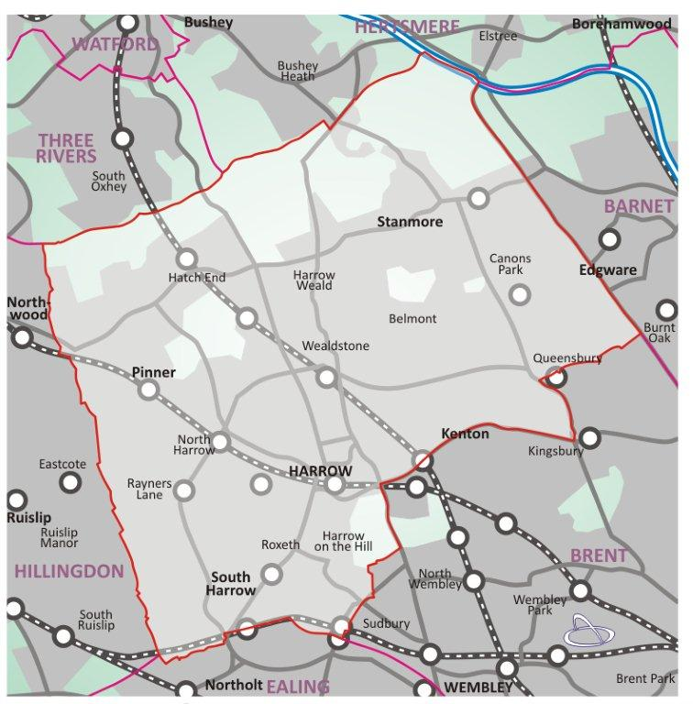

HARROW VIEW EAST Plot C2B | P/2245/20

HARROW VIEW EAST Plot C2B

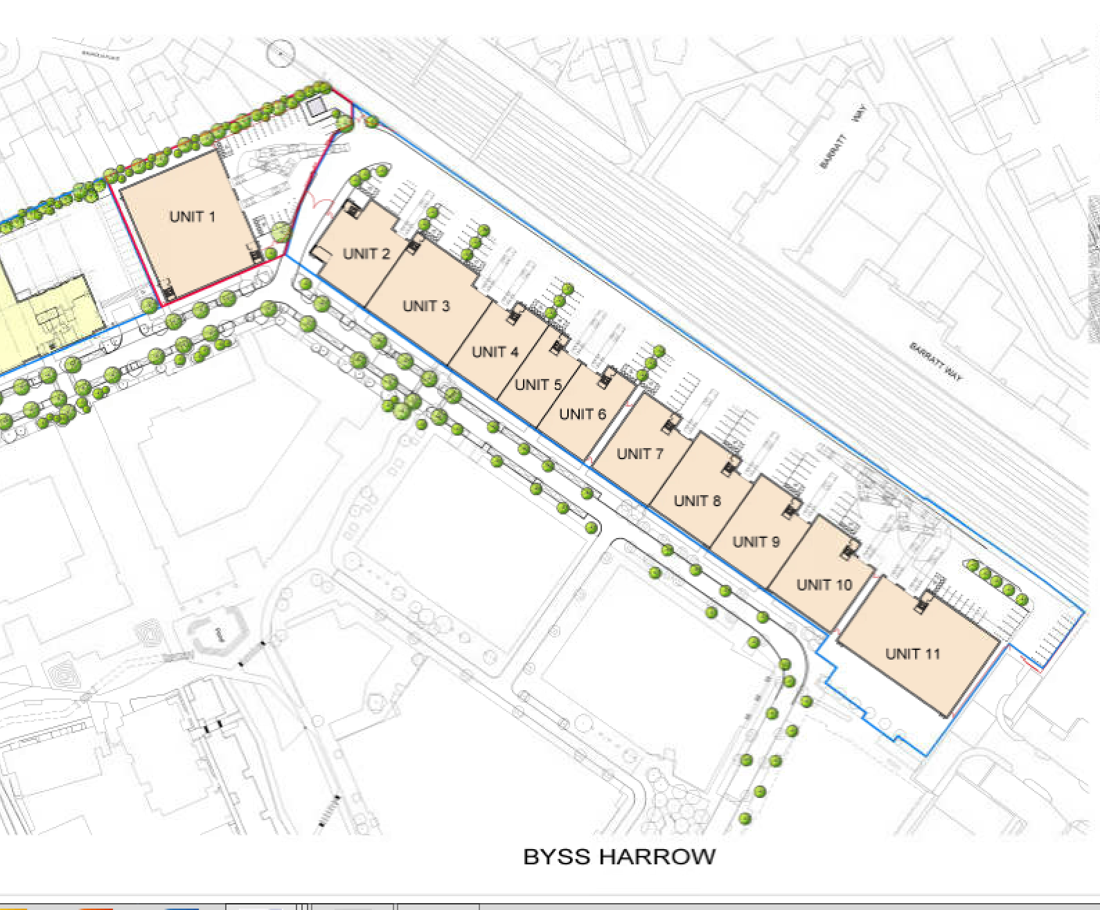

LONDON BOROUGH OF HARROW

PLANNING COMMITTEE

23rd September 2020

APPLICATION NUMBER: | P/2245/20
VALIDATE DATE: | 10/09/2019
LOCATION: | PLOT C2B (DEVELOPMENT ZONE C) OF HARROW VIEW EAST MASTERPLAN SITE  HARROW VIEW EAST (FORMER KODAK FACTORY SITE)  HEADSTONE DRIVE  HARROW
WARD: | MARLBOROUGH
POSTCODE: | HA1 4TY
APPLICANT: | HARROW VIEW LLP - MR TOM OXLEY
AGENT: | DWD LLP
CASE OFFICER: | MATT KOLASZEWSKI
EXPIRY DATE: | 01st OCTOBER 2020

PROPOSAL

Full planning application for the Construction of one industrial unit (Use Classes B1c and B8) and associated vehicle Access, Parking and landscaping

The Planning Committee is asked to:

RECOMMENDATION A

- agree the reasons for approval as set out in this report, and

- Grant planning permission subject to the Conditions listed in Appendix 1 of this report:

- Highways and Parking
Travel Plan
- Submission of a travel plan based on the framework travel plan for each phase of development prior to occupation and to cover an initial monitoring period of 5 years
- Appointment of a travel plan co-ordinator.

- Employment and Training Plan
- Payment of local Employment Contribution to the Council upon commencement of development and to be used towards employment and training initiatives within the Council’s administrative area.
- Submission of an employment, training and recruitment plan to the Council for its approval

- Legal Costs and Monitoring Fee
- Payment of section 106 monitoring fee upon completion of section 106 agreement (amount TBC)
- Payment of all reasonable legal fees upon completion of section 106 agreement

RECOMMENDATION B

That if the Section 106 Agreement is not completed by 23rd December 2020 or as such extended period as may be agreed by the Interim Chief Planning Officer, then it is recommended to delegate the decision to REFUSE planning permission to the Chief Planning Officer on the grounds that:

The proposed development, in the absence of a Legal Agreement to provide appropriate improvements, benefits and monitoring that directly relate to the development, would fail to adequately mitigate the impact of the development on the wider area and provide for necessary social, environmental and physical infrastructural improvements arising directly from the development, contrary to the National Planning Policy Framework (2019), policies 3.11, 3.13, 5.2, 6.3, 7.4, 7.5 and 7.6 of The London Plan (2016), Core Strategy (2012) policy CS1, policies AAP3, AAP13 and AAP19 of the Harrow and Wealdstone Area Action Plan(2013) and policies DM1, DM2 DM42, DM43 and DM50 of the Harrow Development Management Polices Local Plan and the Supplementary Planning Document: Planning Obligations (2013).

REASON FOR THE RECOMMENDATIONS

The principle of development on the former factory site has been established under outline planning application permission P/2165/15 which was approved by the Planning Committee in 2015. The outline permission was granted with all matters reserved for a comprehensive mixed use redevelopment of the Kodak Factory Site.

The proposed scheme seeks to provide new employment floorspace, which is considered a suitable use within the wider site. The decision to grant planning permission has been taken having regard to the National Planning Policy Framework (2019), the policies of The London Plan (2016), Harrow’s Core Strategy (2012), the policies of the Harrow and Wealdstone Area Action Plan (2013) and the policies of the Harrow Development Management Policies Local Plan (2013), as well as to all relevant material considerations including the responses to consultation.

INFORMATION

This application is reported to Planning Committee as it is a Major Development and therefore falls outside Schedule 1 of the Scheme of Delegation.

Statutory Return Type: | Large scale major development
Council Interest: | None
GLA Community Infrastructure Levy (CIL) Contribution (provisional): | £6,659,820 (no social housing discount applied and would be payable on a phased basis)
Local CIL requirement: | £12,198,770 (no social housing discount applied and would be payable on a phased basis)

HUMAN RIGHTS ACT

The provisions of the Human Rights Act 1998 have been taken into account in the processing of the application and the preparation of this report.

EQUALITIES

In determining this planning application the Council has regard to its equalities obligations including its obligations under section 149 of the Equality Act 2010.

For the purposes of this application there are no adverse equalities issues.

S17 Crime & Disorder Act

Policies 7.3.B and 7.13.B of The London Plan and Policy DM1 of the Development Management Polices Local Plan require all new developments to have regard to safety and the measures to reduce crime in the design of development proposal. It is considered that the development does not adversely affect crime risk.

- SITE DESCRIPTION

  - The land to which this application relates is outlined in red on the accompanying Site Location Plan, which extends to approximately 0.317 hectares (3,170m2) and includes the entirety of Plot C2b at Harrow View East. The blue line marks the additional area under the ownership of the Applicant at Harrow View East, which includes the entirety of both Development Plots C2 and D3. Plot C2b comprises the north-eastern corner of the wider Harrow View East masterplan area which, until recently, accommodated series of buildings that formed part of the former Kodak Factory complex.

  - However, these have now been demolished and the Application Site is now cleared. The Application Site is bordered by residential properties to the north (off Magnolia Place), Plot C2a to the west, and Plot D3 and a railway line to the east. As set out above, reserved matters applications have been submitted concurrently with this application for the construction of a new Big Yellow self-storage facility and flexible office space on Plot C2a and 10 speculatively designed employment units on Plot D3. To the south, and on the southern side of the new internal estate road (‘Avenue North’), is an emerging residential neighbourhood that will is colloquially known as ‘Eastman Village’.

  - The wider masterplan site was previously occupied by Kodak Factory which included a range of industrial, logistical and administrative office buildings including the main powerhouse chimney, which is the tallest structure on the site. The wider site is in the process of demolition works, with the exception of the main chimney which is to be retained and the administrative office.

  - The site lies within the wider Harrow and Wealdstone Opportunity Area, as defined in the London Plan and in terms of area is the largest strategic site in this designation. In addition, the site falls within the Wealdstone West sub area Site 2 (Kodak and Zoom Leisure). The site allocates a minimum output of 1,230 jobs and 985 new homes to be achieved through a comprehensive mixed use led redevelopment of the site.

1.5 The outline permission granted under P/2165/15 for the wider masterplan site secures the provision of up to 1,800 residential units a mix of uses comprising business and employment uses up to 32,360 sqm, senior living accommodation and assisted living care home up to 10,230 sqm, foodstore, flexible active uses (within Use classes A1-A5, B1a and D1) (up to 2,000 sqm), leisure and community uses, health centre, a primary school, energy centre together with new streets and other means of access and circulation; highway improvements; associated parking (including a multi-storey car park (Sui Generis use)(up to 8,900sqm)); re-profiling of site levels; utilities diversions and connections; open space; landscaping and ancillary development including infrastructure, works and facilities.

1.6 The approved parameter plans for this new outline planning permission split the Kodak factory site into four zones (Zones A, B, C and D) and the Application Site sits within Zone C adjacent to the Development Zone D boundary, which is proposed to be amended via a separate non-material amendment application.

1.7 A non-material amendment application was also submitted concurrently with this application (and has been subsequently approved) , which seeks confirmation that the following is non-material: “Non-material amendments to outline planning permission P/2165/15 to amend the approved parameter plans and the wording in the Development Specification and Design Guidelines.”

1.8 Of relevance to Plot C2b, the non-material amendment application seeks to make the following changes to the approved parameter plans:
i. Development Plot C2 is proposed to be split into two plots (C2a and C2b) on the parameter plans. The extent of these plots is to reflect what would be the operational area of the aforementioned new Big Yellow self-storage facility on Plot C2a and Plot C2b, which is the subject of this application. This change is reflected on all four of the amended Parameter Plans; and
ii. The extent of Plot D3 is also proposed to be expanded to include a new access road to the rear service yard. This change is reflected on all four of the amended Parameter Plans;

- PROPOSAL

  - The proposed seeks full planning permission construction of one industrial unit (Use Classes B1c and B8) and associated vehicle access, parking and landscaping.

  - The Proposed Development comprises the construction of an employment building, colloquially known as ‘Unit 1’ to provide floorspace for either class B1c and/or B8 uses. This unit will provide 1,563m2 of gross internal floor space (Use Class B1(c)/B8).

  - Unit 1 would be built on a speculative basis meaning that, at this stage, there is no confirmed tenant for this unit, however it is anticipated that there will be strong interest if approval is granted. Supporting this unit is provision of office floorspace at mezzanine level, which will be ancillary to the primary use of the building (either B1c/B8) and not a separate, dedicated office under use class B1(a).

  - It is acknowledged that the Outline Permission also allows other Class B1 uses on this plot, such as offices. However, the Applicant is of the opinion that Harrow office occupiers are local in nature and tend to occupy smaller office floor plates (sub-5,000 sq. ft). This has led to a surplus of secondary office space in the town, which has subsequently been converted to residential use under permitted development rights or full planning applications (i.e. The Hub and Queens House). The Application Site is situated outside of the prime Harrow-on-the-Hill location and will therefore attract limited occupational demand. For this reason, the Applicant has decided to not apply for potential office use in the industrial unit.

  - The building will be a self contained employment unit with its own dedicated service yard. It’s use will fall under class B1c and B8. The unit will be built to accommodate a range of potential occupiers. Unit 1 will benefit from its own dedicated and contained service yard. It will have a secure perimeter fence and gates allowing it to secure its yard independently of the rest of the employment units. Offices to the first floor mezzanine are positioned to the south to face the estate road and provide a more active frontage to the building. This is also the preference as to avoid office windows looking out onto residential properties. Vehicle parking will be provided throughout the site for employee parking. In terms of the quantities for employment unit 1 there are 18no. parking bays , of which 2 are to be accessible.. Cycle storage proposed is 1no. Sheffield style cycle shelters, capable of housing 8no. cycles.

  - The Proposed Development would accommodate between 24 and 30 FTE jobs. The reason for this range is the unknown nature of the final occupiers of this floorspace. The actual employment yield is likely to fall within this range.

- RELEVANT PLANNING HISTORY

3.1 A summary of the relevant planning application history is set out in the table below:

Ref no.  Description | Status and date  of decision
P/3405/11  Outline planning application for a comprehensive, phased, mixed use development of land at Harrow View and Headstone Drive, as set out in the Development Specification (March 2012). The development comprises the demolition of existing buildings and structures (with the exception of the chimney and part of powerhouse) and redevelopment of the site for a mix of uses comprising business and employment uses (within Use Classes B1(a), B1(b), B1(c), B2 and B8 - up to 35,975sqm); residential dwellings (within Use Class C3 - up to 985 units); student accommodation (Sui Generis use - up to 220 units); senior living accommodation (within Use Class C2); assisted living care home (within Use Class C2) (total C2 uses up to 9,300sqm); retail and restaurant uses (within Use Classes A1, A2, A3, A4 and A5 - up to 5,000sqm); commercial leisure uses (Use Class D2); community uses (Use Class D1); health centre (Use Class D1); a primary school (Use Class D1) (total D1/D2 uses up to 8,830sqm); energy centre (Sui Generis use - up to 4,500sqm); together with new streets and other means of access and circulation; highway improvements; associated parking; re-profiling of site levels; utilities diversions and connections; open space; landscaping and ancillary development including infrastructure, works and facilities. | Granted  21/12/2012
P/2182/15  Modification to section 106 planning agreement relating to planning permission P/3405/11 dated 21 December 2012 as varied by a deed of variation dated 22 December 2014 to define and split the obligations between the East Land (Harrow View East) and West Land (Harrow View West) | Approved  9/12/2015
P/2165/15  Outline planning application (all matters reserved) for a comprehensive, phased, mixed use development of land at Harrow View and Headstone Drive (known as Harrow View East), as set out in the Development Specification (September 2015). The development comprises the demolition of existing buildings and structures (with the exception of the chimney and part of powerhouse) and redevelopment of the site for a mix of uses comprising business and employment uses (within Use Classes B1(a), B1(b), B1(c), B2 and B8) (up to 32,360 sqm); residential dwellings (within Use Class C3) (up to 1800 units); senior living accommodation and assisted living care home (both within Use Class C2) (up to 10,230 sqm); foodstore (within Use Class A1) (up to 2,000sqm); Flexible active uses (within Use classes A1-A5, B1a and D1) (up to 2,000 sqm); leisure and community uses including commercial leisure uses (Use Class D2); Community uses (Use Class D1), health centre (Use Class D1); a primary school (Use Class D1) (total D1/D2 uses up to 9,730sqm); energy centre (Sui Generis use)( up to 600sqm) (including an interim energy centre in Phase C (up to 200sqm); together with new streets and other means of access and circulation; highway improvements; associated parking (including a multi-storey car park (Sui Generis use)(up to 8,900sqm)); re-profiling of site levels; utilities diversions and connections; open space; landscaping and ancillary development including infrastructure, works and facilities. | Granted  09/12/2015
P/4367/17  Non-Material Amendment To Planning Permission P/2165/15 Dated 09/12/2015 To Allow Changes To Access Points The Green Link Height Locations And Phasing Boundaries (Development Zones B, C and D only). | Approved  24/10/2017
P/5023/17  Non-Material Amendment To Planning Permission P/2165/15 Dated 09/12/2015 To Allow Changes To Access Points The Green Link Height Locations And Phasing Boundaries (Development Zones B, C and D only) | Approved  20/12/2017
P/5079/17  Approval of all reserved matters for development plot D7 and the Green Link of Development Zone D of the Harrow View East Masterplan and details pursuant to conditions 7(Urban Design Report), 8(Energy Strategy), 9(Ecology and Biodiversity Strategy), 11(Housing Schedule), 12(Daylight and Sunlight Assessment), 13(Surface Water Drainage Strategy), 14(Accessibility Strategy), 15(Lighting Strategy), 16(Refuse Strategy), 17(Noise and Vibration Strategy), 18(Arboricultural Strategy), 19(Landscaping), 20(Transport Strategy), 21(Levels), 22(Open Space Strategy) following outline planning permission granted under P/2165/15 dated 09.12.2015 for the comprehensive phased, mixed use development of land bounded by Harrow View and Headstone Drive (known as Harrow View East) | Approved  02/02/2018
P/5244/17  Demolition of existing building surrounding factory chimney, retention of existing chimney and construction of a new building comprising an energy centre (Sui Generis) and a flexible community space (Use Class D1/D2) | Granted  05/02/2018
P/3004/18  Non-material amendment to planning permission P/2165/15 dated 9/12/2015 to correct factual inaccuracies associated with the approved parameter plans and enable non-material changes to the approved parameter plans (zonal boundaries, limits of deviation and building heights) | Approved  03/08/2018
P/3892/18  Approval of all reserved matters for development Plots B1 and C1 and sections of the Green Link of Development Zones B and C of the Harrow View East Masterplan and details pursuant to Conditions 7 (Urban Design Report), 8 (Energy Strategy), 9 (Ecology and Biodiversity Strategy), 11 (Housing Schedule), 12 (Daylight and Sunlight Assessment), 13(Surface Water Drainage Strategy), 14 (Accessibility Strategy), 15 (Lighting Strategy), 16(Refuse Strategy), 17 (Noise and Vibration Strategy), 18 (Arboricultural Strategy), 19(Landscaping), 20 (Transport Strategy), 21 (Levels), 22 (Open Space Strategy) following outline planning permission granted under P/2165/15 dated 09.12.2015 for the comprehensive phased, mixed use development of land bounded by Harrow View and Headstone Drive (known as Harrow View East) | Approved 06/12/2018
P/2280/19  Non-Material Amendment To Outline Planning Permission P/2165/15 Dated 9.12.15 To Reword Condition 2 To Exclude Enabling Works | Approved  14/06/2019
P/4046/18  Non-material amendment to reserved matters permission P/5079/17 dated 2/2/18 to enable amendments to approved reserved matters plans (FFLs for all blocks, window positions, window and door types, internal layout of homes, Block B gallery access, Block F1 communal entrance, perforated panels to the podium, boundary wall and re-location of existing substation) | Approved  9/07/2019
P/3944/19  Full planning application for the development of Plots D1, D2, D4, D5 and D6 at Harrow View East (former Kodak Factory) for residential dwellings (use class C3 - including an Extra Care Facility), café/restaurant space (Use Class A3), flexible active uses (Uses Classes, A1, A2, B1(a) and D1); together with new roads and other means of access and circulation, associated car and cycle parking, open space, landscaping and ancillary development including all necessary infrastructure works | Granted subject to S106 Agreement
P/0344/20  Non-material amendment to Reserved Matters permission P/3892/18 dated 6.12.18 to enable changes to the adopted road layout in Plot C1 | Approved  17/04/2020

- CONSULTATION

4.1 A Site Notice was erected on 09.07.2020 expiring on 06.08.2020.

4.2 Press Notice was advertised in the Harrow Times on the 16.07.2020 expiring on 13.08.2020.

4.3 The application was advertised as a major application.

4.4 A total of 1931 notification letters were sent to nearby properties regarding this application.

4.5 The public consultation period expired on 17.10.2019

4.6 Adjoining Properties

Number of letters Sent | 1931
Number of Responses Received | 9
Number in Support | 0
Number of Objections | 9
Number of other Representations (neither objecting or supporting) | 0

4.7 9 objections were received from adjoining residents.

4.8 A summary of the responses received along with the Officer comments are set out below:

Social-Economic
- 24 hr operation will cause security problems

Officer Comments: The applicant has engaged the Designing Out Crime Officer (DOCO) for Harrow in developing the proposed development. The DOCO has also been formally consulted on this application and does not raise any objection subject to ensuring appropriate surveillance and safety is incorporated as part of the detailed design. The development as discussed in the appraisal below would create a new neighbourhood to this section of Wealdstone and would bring forward new public realm and population to an area which is bleak and disused.

Both national and regional development plans direct new growth to previously developed land and encourage that where suitable densities should be maximised. Further justification is set out under the ‘Principle of Development’ section of the appraisal.

Character
- Green Corridor is a gimmick as trees will take year to grown.

Officer Comment: The impact on the character and townscape has been addressed under ‘Character and Appearance’ and ‘Impact on Protected Views’ sections of the appraisal below.

Overshadowing
- The height and proximity (of Unit 1) near our boundary fence will cause significant overshadowing in the gardens.
- The unit will have major impact on sunlight in our garden.

Officer Comment: impact on daylighting and overshadowing has been addressed under ‘Residential Amenity’ section of the appraisal below. This concludes that there would be no impact on any properties adjoining the wider masterplan site in terms of overshadowing.

Traffic and Highways
- Roads are unable to cope;
- Traffic is already unbearable.
- Traffic in industrial units which are right next to property boundaries;
- Noise form HGV Traffic
- Noise and traffic from construction work and vehicles

Officer Comments: The impact on the surrounding highway in terms of congestion, parking, transport services and air pollution has been addressed under ‘Traffic, Parking, Access, Servicing and Sustainable Transport’ and ‘Air Quality’ sections of the appraisal below.

Other matters

2. Placing local residents health at risk and highway safety
3. Use of hazardous materials
5. Increased noise and disturbance resulting from use
6. Loss of trees
7. Smells
8. Layout and density of building: when housing is an issue in the area, to waste land on industrial site is appalling.
9. Height of building will not fit with the local area

Officer Comments: These comments are addressed within the report.

4.9 Statutory and Non Statutory Consultation

4.10 The following consultations have been undertaken:

LBH Environmental Health

No comments received.

LBH Drainage

The Drainage Strategy submitted by the applicant seems fine, however the following details are still required and can be conditioned.

• The applicant should submit a detailed drainage design in line with our standard requirements attached.
• The applicant should consult Thames Water developer services by email: developer.services@thameswater.co.uk or by phone: 0800 009 3921 or on Thames Water website www.developerservices.co.uk regarding capacity of their public sewers for receiving discharge from the proposed development. The Thames Water confirmation letter should be submitted.
• Please request the applicant to submit a section drawing of the storage tank with levels as we need to make sure that it is provided below the lowest point in the system.
• Please request the applicant to submit a cross section of permeable paving construction with full details and their maintenance plan for our approval.
• Please advise the applicant to contact vehicle crossing team on VehicleCrossings@harrow.gov.uk regarding access arrangements.

Please be informed that the requested details can be conditioned, attached are our standard drainage conditions/ informative for reference.

LBH Highways

No objection subject to construction plan condition. The comments are reported in more detail in the highways section of this report.

LBH Planning Policy

No comments have been received thus far. Any comments received prior to the committee meeting will be reported in the addendum.

LBH Design

No Objection

LBH Conservation Officer

No comments. This is too far from any heritage assets to comment.

LBH Landscape Architects

No objection subject to appropriate landscape conditions.

LBH Waste Officer

No comments received

LBH Economic Development

The Economic Development Team welcomes the development of the site for employment uses and the proposed 30 full time jobs related to the application.

1. As a major application, we will be seeking the following to be included in any s106 agreement:
• Construction Training – a requirement to produce a training and employment plan and a provide financial contribution
• Local Supplier targets

Further details are set out below.

2. The Economic Development team would also welcome working with and supporting the developer and end users of the building(s) through the services that it offers in relation to employment and training and business support.

Construction Training
As a major application, Economic Development will be seeking construction employment opportunities on site in line with Policy E11 Skills And Opportunities For All of the London Plan.

This will be secured through
(i) a training and employment plan that will be agreed between the council and the developer prior to start on site and
(ii) a financial contribution towards the management and delivery of the construction training programme based on the build cost of the development. This is usually charged based on a formula of £2500 per £1m build cost.

The Training and Employment Plan will set out how outreach, initial assessment, job-search support, vocational training and job brokerage will be delivered to ensure residents benefit from the development. It will include:
a) employment opportunities relating to the construction of the Development and details of sector delivery; this could include the number of apprenticeships provided on site, the number of local people employed on site and upskilling opportunities provided.
b) the provision of appropriate training with the objectives of ensuring effective transition into work and sustainable job outcomes;
c) the timings and arrangements for implementation of such initiatives and
d) suitable mechanisms for the monitoring of the effectiveness of such initiatives

Monthly performance reports to the council’s Economic Development Team will provide progress against the agreed targets in the Training and Employment Plan.
The Economic Development Unit is able to provide further information and guidance to the applicant if required. However as guidance,
- the number of jobs to be created during the construction of the development may be calculated by construction weeks and divided by 52.
- the Planning Obligations SPD sets out a target of 1 apprentice per £3m spend.
The financial contribution will fund the delivery of the plan which will include a contribution to the salary costs for an Employment and Training Co-ordinator who will discharge the activities in the Plan.
Penalty Clauses
Any s106 agreement will include penalty clauses for non-compliance with the above. Non-compliance is failure to deliver the obligations in the section 106 Agreement, irrespective of whether
a) the Agreement states that it will discharge the obligation
b) the Developer has paid the council (Xcite) to employ a training and employment co-ordinator and beneficiary funds to discharge the obligations, but the developer’s contractors fail to work with Xcite to provide skill, apprenticeship and employment opportunities.
HB Law has been working on relevant clauses.
Local Supplier Targets
To ensure local businesses benefit from the investment in the area, the Economic Development Team require that 15% of spend during the construction of the development is with suppliers in the council’s administrative area. Full comments have been incorporated noted in the appraisal below

4.11 The comments of the consultees are addressed within the relevant sections of the assessment.

External Consultation

4.12 A summary of the consultation responses received along with the Officer comments are set out in the Table below.

Thames Water

Water Comments
No water comments

Supplementary Comments

Thames Water do not have capacity for these plots or the wider Kodak Site development. Modelling is being undertaken by Thames Water and the phasing of the Kodak Site shows there will be no occupation until September 2022. Thames Waters current program indicates that we will have completed reinforcement works for the whole of the Kodak Development site by the end of December 2021. As a result of this Thames Water do not raise any concerns. If the phasing plan we have been provided was to be incorrect or to change then Thames Water would need to be contacted and concerns would be raised as our program of works has been planned out and we only have capacity once the works are completed.

Officer Comment: Noted. An informative would be attached advising the applicant of the above.

Health and Safety Executive
No comments received.
TfL Infrastructure
No objection
Design Out Crime Officer

To follow

Historic England (GLAAS)
No comments received
Historic England (Listed Buildings)
No comments received
Network Rail
No comments received

5.0 POLICIES

5.1 Section 38(6) of the Planning and Compulsory Purchase Act 2004 requires that:

‘If regard is to be had to the Development Plan for the purpose of any determination to be made under the Planning Acts, the determination must be made in accordance with the Plan unless material considerations indicate otherwise.’

5.2 The National Planning Policy Framework (NPPF) sets out the Government’s planning policies for England and how these should be applied; it is a material consideration in the determination of this application. The current NPPF was published in July 2018 and was updated in February 2019.

5.3 In this instance, the Development Plan comprises The London Plan 2016, The Harrow Core Strategy 2012 [CS], Harrow and Wealdstone Area Action Plan (AAP) 2013, the Development Management Policies Local Plan 2013 [DMP], the Site Allocations Local Plan SALP 2013 [SALP].

5.4 While this application has been principally considered against the adopted London Plan (2016) policies, some regard has also been given to relevant policies in the Draft London Plan (2017), as this will eventually replace the current London Plan (2016) when adopted and forms part of the development plan for the Borough.

5.5 The document was originally published in draft form in December 2017 and subject to Examination in Public (EiP) with the Panel’s report published in October 2019. The Mayor of London has considered these recommendations, and has either accepted them or where not, provided justification as to why accepting them would not be appropriate. The Mayor has now submitted to the Secretary of State an ‘Intend to Publish’ version of The Plan. It is for the Secretary of State to determine whether he agrees with the revised Plan and it ought to be published in that form.

5.6 The Draft London Plan is a material planning consideration that holds significant weight in determining planning applications, with relevant polices referenced within the report below.

6.0 ASSESSMENT

6.1 The main issues are;

Principle of the Development
Regeneration
Environmental Impact Assessment
Heritage and Impact on Protected Views
Character and Appearance of the Area
Residential Amenity, Quality, Noise and Accessibility
Traffic, Parking, Access, Servicing and Sustainable Transport
Development and Flood Risk
Biodiversity
Sustainability and Climate Change Mitigation
Air Quality
S.106 Obligations and Infrastructure

6.2 Principle of Development

6.2.1 The relevant policies are:
NPPF
The London Plan: 2.13, 3.4 and 4.7B
Harrow Development Management Local Policies: DM35
Harrow and Wealdstone Area Action Plan: AAP3, AAP4 and AAP17
Draft London Plan: GG2, SD7 and H1

6.2.2 The subject site is located within the “Heart of Harrow” which encompasses the two town centres of Harrow and Wealdstone, the Station Road corridor linking the two centres, and the industrial land and open spaces surrounding Wealdstone, including the Kodak site, Headstone Manor and the Harrow Leisure Centre.

6.2.3 The Heart of Harrow is designated as an Opportunity Area in the 2016 version of the London Plan and the outline permission granted under P/2165/15 was approved on the basis of this designation. The Opportunity Area designation is expected to contribute to the delivery of 3,000 jobs and a minimum of 2,800 new homes within the Area through higher density residential and mixed use development on key strategic sites.

6.2.4 The principle of redevelopment of the Kodak factory site has been long established through the approval of two outline permissions under refs: P/3405/11 and P/2165/15 for the comprehensive phased mixed redevelopment of the former factory site. As such, the principle of development on HVE Phase III is supported.

6.2.5 The wider masterplan site is identified as a development opportunity site in the AAP and falls within the Wealdstone West sub area Site 2. The site allocates a minimum output of 1,230 jobs and 985 new homes to be achieved through a comprehensive mixed use led redevelopment of the former factory site. The site allocation consolidates designated strategic industrial land (SIL) to the northern and eastern parts of the former factory site (identified as development plots C2 and D3 on the approved masterplan) and to the southern western corner of the site where the former Kodak administrative building remains (located on the southern half of development plot B1).

6.2.6 The approved masterplan plan under P/2165/15 divides the site into four different development zones, which are further split into development plots. Whilst the masterplan was granted outline permission with all matters reserved, there are certain parameters that are fixed under this outline permission, which includes the amount of open space to be provided, the heights of the buildings, access point and primarily route through the site. The parameter plans also fixes the floor spaces for different uses to be provided within each development phase and the number of residential units.

6.2.7 The Application Site is located within Harrow View East, which is one of the largest regeneration areas in the Borough. There is an extant outline planning permission for Harrow View East and details pursuant to a number of conditions imposed on the Outline Permission have been approved as part of enabling works to clear and remediate the Application Site for its delivery. The principle of development has therefore been established by the Outline Permission.

6.3 Regeneration

6.3.1 It is inevitable that the character of the area will significantly change through the intensive urbanisation of the area as a result of the high density of development. However, the increase in density in this location is vital to support the wider regeneration of Wealdstone Town Centre and its surrounding area through sustained economic growth and job creation.

6.3.2 As noted above, the subject site sits within the wider masterplan area and would support the wider aspirations of the masterplan site through delivering high quality development and mixed communities. The cumulative proposals delivered on this strategic site would not only in itself regenerate the immediate area, but would release essential contributions, already secured under the outline permission P/2165/15 to enable the Council to improve the surrounding public realm and the connectively between the site and Wealdstone Town Centre, all of which are considered integral to ensure the successful regeneration of the local area.

6.4 Heritage and Impact on Protected Views

6.4.1 The relevant policies are:
NPPF: Chapters 12 and 16
London Plan: 7.4. 7.6, 7.7 and 7.8
Harrow Development Management Local Policies: DM1, DM3 and DM7
Harrow and Wealdstone Area Action Plan: AAP3, AAP6 and AAP8
Draft London Plan: D1

6.4.2 The height of the building is low and would not impact on any protected views.

6.5 Character and Appearance of the Area

6.5.1 The relevant policies are:
NPPF: Chapter 12
London Plan: 7.4., 7.5, 7.6, 7.7 and 7.13
Harrow Development Management Local Policies: DM1, DM22, DM23 and DM45
Harrow and Wealdstone Area Action Plan: AAP3, AAP4 and AAP6
Draft London Plan: D1, D3 and D11

6.5.2 The surrounding area is mixed in character. To the south and west of the wider masterplan site the area is characterised by interwar residential development, largely two storeys, but interspersed with two to four storey high flatted developments. To the east of the site, the character is defined by commercial and industrial development. Buildings are low rise and range from one to three storeys in height. Further east and past the railway lines, the character is defined by Victorian and Edwardian residential terraces, two storeys high.

6.5.3 As noted above, within the wider character setting, the grounds of Headstone Manor with its number of Grade I and Grade II listed buildings and Scheduled Monument moat are located approximately 600m from the subject site.

6.5.4 The subject site is located within the wider Harrow View East masterplan site which until recently, was occupied by disused industrial buildings associated with its former by Kodak. The buildings and the chimney formed landmarks within the townscape due to their contrasting height and form. The former sports grounds is currently being redeveloped pursuant planning permission granted under outline application P/3405/11. The main factory site is also being redeveloped pursuant to outline permission granted under outline application P/2165/15.

6.5.5 Development proposals are required by policy to be of high-quality design, and need to reflect the surrounding local character and respect local patterns of development. The proposed development is the result of a design-led approach that has evolved holistically along with a proposed Big Yellow self-storage facility on Plot C2a and 10 speculative employment units on Plot D3. The evolution of the design has taken place through extensive discussions with the Borough’s Design Officer.

6.5.6 The outline consent set a height parameter on the northern boundary of the site. The storage building design sits within this parameter. The composition of the west elevation on Harrow view however necessitated a taller elevation. Studies were carried out to determine the best way to resolve the height difference.

6.5.7 In general, the design has responded sensitively to the characteristics of the surrounding existing and emerging built environment. The layout of the proposal efficiently utilises the amount of land it requires in order to maximise the developable area.

6.5.8 The scale of the proposed unit has been chosen to reflect what is anticipated to be most attractive to the type of tenants sought. Originally, it was thought that the design of the building could comply with the approved height parameters of the Outline Permission but this would have resulted in a building that would not be suitable to the market. Notwithstanding, it is only part of the rear pitch of the building that slightly exceeds the approved height parameters. The rear of the roof on unit 1 will rise to a maximum of 2.9m above the 8m max parameter height. The eaves height as it adjoins the neighbouring residents’ gardens complies with the parameters.

6.5.9 The rear of the roof has a Plot C2b, Harrow View East Planning Statement 28 shallow pitch and rises gradually meaning the exceedance of the parameter gradually rises up to a maximum of 2.9m at the pitch of the roof. Given the pitch rises gradually (2.9m over 14.8m), there will be no visual impact from the residential properties on Magnolia Place whose gardens are long. The external appearance of the proposed building has been designed to respond in a manner that is in keeping with the emerging commercial and residential context. This will therefore accord with Development Management Policies DM1 and DM3.

Landscaping

6.5.10 As part of the outline planning application, East Architects worked with Outerspace to identify a strategy for the wider landscape and set out how the scheme should respond to its landscape context. The landscape strategy was based on the industrial history and promoted a landscape character that responds to the organic breaking down of forms. This combines well with the Outerspace ‘human-nature’ objective of supporting both mental and physical welfare and the connectivity to biodiversity.

6.5.11 This approach has been taken forward and further promoted within this application, creating a landscape scheme that helps to achieve a sense of belonging: to the place, the time and the community. The paving strategy similarly celebrates the building entrances with good quality slabs of a smooth surface. Adjacent strips of hard surfacing are paved with a more textured sett, whilst resin bound gravel is used to pave and highlight pedestrian routes along the rear of the buildings.

6.5.12 The Landscape Masterplan is divided into a series of sub-zones and the units 1 and 2 environs subzone contains a pivotal ‘knuckle’ space at the bend of the Primary Road. Comments from East have Architects have been taken on board in the design of this area, together with the rear parking courtyard and the treatment of the boundary with the railway embankment.

6.5.13 The view through this space from the Primary Road towards the sub-station is seen to be key in the overall experience and so we are proposing a clump of trees to provide a feature terminating the view, framed by a specimen tree outside the Unit 1 entrance. Throughout the parking courtyard there are rows of tree planting to break up the space and provide a softening to the environment. These will furthermore provide seasonal interest. Along the boundary to the railway embankment we are providing an acoustic fence together with a clipped naturalistic hedge. This feature containing all the species of a hedge within the English countryside such as hawthorn, blackthorn, dog rose, honeysuckle and elder, will provide a great source of nectar, fruit and refuge for birds, bees, butterflies and other insects. Furthermore, bird boxes will be put on the fence elevation.

6.5.14 Overall, the landscaping strategy proposed would integrate with the wider masterplan site and would provide a high quality finish. The detailed landscaping strategy and detailed planting together with the maintenance and management plan will be secured by condition.

Conclusion

6.5.15 In conclusion, the proposed development, subject to the imposition of appropriate conditions would achieve a high quality form of development which would be further enhanced by the landscaped strategy which will knit together with the wider masterplan. It is considered that the proposals would meet the high quality design and landscape aspirations in accordance with the policies.

6.6 Residential Amenity, Quality, Noise and Accessibility

6.6.1 The relevant policies are:
NPPF: Chapter 8
London Plan: 3.5, 3.6, 3.7, 7.6 and 7.15
Harrow Development Management Local Policies: DM1, DM2,
Harrow and Wealdstone Area Action Plan: AAP3, AAP4 and AAP13
Draft London Plan: D4, D5, D6 and D13

Impact of Development on Neighbouring Occupiers and Consented Scheme

6.6.2 The ES accompanying this application provides an impact assessment on daylight, sunlight and overshadowing to in relation to the future occupiers of neighbouring consented scheme.

6.6.3 No. 9 Magnolia place is the closest residential property to the proposed scheme. The analysis shows that the proposed scheme has a lower development angle than the consented maximum parameter massing and that of the existing buildings pre-demolition. Therefore, the impact on this property when compared with the parameter plan will be considerably less.

6.6.4 A detailed analysis has been undertaken which confirms that the reduction in VSC to all windows will be less than 2% and that the majority of windows will in fact experience gains in VSC of up to 2%. Furthermore, the retained VSC values are very good, many exceeding the 25% VSC target. Overall, the daylight impact on neighbouring properties as measured by both VSC and NSL will be negligible and compliant with the BRE guidelines. Similarly, the sunlight impact will be negligible, and all properties will retain sufficient sunlight amenity, achieving APSH values over double the suggested minimum.

Noise

6.6.5 Draft policy D13 of the London Plan relating to ‘Agent of Change’ requires that new noise and other nuisance-generating development proposed close to residential and other sensitive uses should put in place measure to mitigate and manage any impacts. This should be managed through good design mitigation during earlier design stages. Developments should be designed to ensure that established noise and other noise-generating uses remain viable and can continue or grow without unreasonable restrictions being placed on them. It is noted that the current proposal do not increase the quantum of floorspace. The main change is the slight increase in the height of a portion of the building above the maximum height parameters set at outline stage. Notwithstanding the above, the principle of these adjacent uses has already been accepted under the two previous outline permissions.

Conclusion

6.6.6 In conclusion, it is considered that the proposal would not result in any undue impacts on residential amenity, and thus would comply with the relevant policies.

6.7 Traffic, Parking, Access, Servicing and Sustainable Transport

6.7.1 The relevant policies are:
NPPF: Chapter 9
London Plan: 6.3, 6.9, 6.13,
Harrow Development Management Local Policies: DM42, DM43 and DM44
Harrow and Wealdstone Area Action Plan: AAP19 and AAP20
Draft London Plan: H15, T2, T4, T6, T6.1, T6.3 and T6.5

Transport Impact

6.7.2 The proposed development has been assessed against all modes of transports. The TS concludes that the uplift in trips generated by the development will have a relatively low impact on the local highway network.

6.7.3 The application was accompanied by a Transportation Statement, a Travel Plan, and a Delivery and Servicing Plan. Harrow’s Highways officer has noted that the number of trips is likely to be lower than the forecasted amount, given the high levels of available public transportation, and so the proposal would be acceptable in these terms.

6.7.4 The proposal includes car parking which should comply with the maximum standards given in the draft London Plan. This use should be considered similar to office use therefore, the maximum number should not exceed 17 spaces but must include disabled bays and EV charging points in line with London Plan requirements. The ITP standards would require at least two disabled bays. Some further clarity on what the parking provision is intended for is required; is it operational, for staff, for visitors- can the quantum be reduced over time in line with travel planning measures? Electric vehicle charge points should be provided too, particularly for operational uses.

6.7.5 The proposed site layout is acceptable; it has been demonstrated that large HGV’s can enter and exit in a forward gear whilst still allowing for car parking.

6.7.6 Cycle parking should be provided at a minimum of 7 long stay spaces and one short stay. The long stay spaces should be secure, sheltered and accessible (can be used by non-standard cycles). Details of the stores are required.

6.7.7 The trip generation assessment demonstrates that in comparison with the outline application predictions, this proposal is a reduction in expected trips. This is accepted as the proposed use tends to have less staff and trips are more likely to be outside of the peak network hours, particularly the AM period. The analysis doesn’t tell us much about how people would travel in terms of modal splits as the data only includes vehicles. It is understood that people visiting a storage unit are most likely to travel by car but some may walk or use public transport and staff could certainly travel by sustainable means. We also have no information on HGV or commercial vehicle activity although the assessment does make it clear that it is expected. The travel plan will be reviewed separately by the Council’s travel plan officer but at present with some detail missing, it is possible that it will need to be revised. The servicing and refuse management plan should also include more detail on numbers of vehicles expected, frequency and how these could be minimised – this would help to better understand the potential impacts.

6.7.8 Construction logistics information is required for all details applications on this site – this information is necessary to understand how construction will be managed alongside the existing development work that is already taking place and how the impact will be minimised.
This proposal is unlikely to result in a severe or harmful impact for the surrounding highway network.

Conclusion

6.7.9 In conclusion, it is considered that the proposed development, subject to the imposition of appropriate would have no adverse impact up parking or highway safety and consequently would give rise to no conflict with the policies stated under paragraph 6.9.1 above.

6.8 Development and Flood Risk

6.8.1 The relevant policies are:
NPPF: Chapter 14
London Plan: 5.12 and 5.13
Harrow Core Strategy: CS1 U
Harrow Development Management Local Policies: DM9, DM10 and DM12
Harrow and Wealdstone Area Action Plan: AAP9
Draft London Plan: SI 12 and SI 13

Flood Risk
6.8.2 The applicant a Flood Risk Assessment (FRA) for this site. The entirety of the site and surrounding areas are shown to be within Flood Zone 1 i.e. land having a less than 1 in 1,000 annual probability of fluvial or tidal flooding. The FRA confirms that there is negligible risk of tidal flooding.

6.8.3 Wealdstone Brooke and Yeading Brook are located to the east and northwest of the site respectively. Based on the EA’s Flood Risk from Surface Water mapping, the site is considered to be at low risk of fluvial flooding.

6.8.4 The EA’s Surface Water Flood Risk mapping shows that majority of the site to be at ‘low risk’ of surface water flooding. However, there are some isolated areas of potential surface water flooding shown within the site. The FRA states that these areas are isolated and the proposed surface water drainage system will reduce the risk of such potential water flooding/ ponding. Further, the slight gradient across the site means that any overland flows will be directed from the site. The FRA concludes that the site will be at low risk of surface water flooding. In addition, the FRA concludes that the site is at low risk of groundwater flooding. In order to afford the site addition protection from any potential ‘residual’ flood rick, finished floor levels will be set a minimum ‘standard’ of 0.15m above adjacent infrastructure thoroughfare levels.

6.8.5 The FRA has been reviewed by the Council’s Drainage Authority and they have stated that The Drainage Strategy submitted by the applicant is acceptable, however the following details are still required and can be conditioned.

• The applicant should submit a detailed drainage design in line with our standard requirements attached.
• The applicant should consult Thames Water developer services by email: developer.services@thameswater.co.uk or by phone: 0800 009 3921 or on Thames Water website www.developerservices.co.uk regarding capacity of their public sewers for receiving discharge from the proposed development. The Thames Water confirmation letter should be submitted.
• Please request the applicant to submit a section drawing of the storage tank with levels as we need to make sure that it is provided below the lowest point in the system.
• Please request the applicant to submit a cross section of permeable paving construction with full details and their maintenance plan for our approval.
• Please advise the applicant to contact vehicle crossing team on VehicleCrossings@harrow.gov.uk regarding access arrangements.

6.8.6 Subject to the above, the proposal therefore complies with the National Planning Policy Framework (2019), policies 5.12 and 5.13 of The London Plan (2016), policy CS1 of the Core Strategy (2012) and policies DM1, DM9 and DM10 of the Harrow Development Management Policies Local Plan (2013).

6.10 Sustainability

6.10.1 The relevant policies are:
NPPF: Chapters 2 and 14
London Plan: 5.1, 5.2, 5.3, 5.4A, 5.7, 5.9, 5.10, 5.11, 5.15, 5.18, 7.6 and 7.7
Harrow Core Strategy: CS1 T
Harrow Development Management Local Policies: DM1, DM12, DM13 and DM14
Harrow and Wealdstone Area Action Plan: AAP4, AAP6 and AAP10
Draft London Plan: D7, D8, G5, S1 2, SI 3, S1 4, SI 5 and SI 7

6.10.2 The relevant policies are 5.1, 5.2, 5.3, 5.4, 5.6, 5.7, and 5.9 of The London Plan (2016), SI 1, SI 2, SI 4, SI 5 of the Draft London Plan (2019), CS.1 and CS.2 of the Harrow Core Strategy (2012); AAP4 and AAP10 of the Harrow and Wealdstone Area Action Plan (2013) and policies DM12, DM13 and DM14 of the Development Management Policies Local Plan (2013).

6.10.3 All major applications are required to achieve a 35% reduction (on site) in carbon dioxide emissions over the Building Regulations 2013; and 0% overall. The applicant should follow the hierarchy and policy guidance within the Draft New London Plan (2019). In addition, Policy 5.7 (Renewable Energy) requires new development to provide a reduction in expected carbon emissions through on-site renewable energy, where feasible. The supporting text to the policy indicates there is a presumption that the reduction achieved through on-site renewable energy will be at least 20%.

6.10.4 Both an Energy Statement and a Sustainability Statement have been submitted with this application. The Energy Statement states that energy efficiency measures will be implemented to provide a carbon saving of 17% in comparison to the Target Emission Rate regulated emissions.

6.10.5 The energy efficiency measures include: good fabric insulation, improved air tightness, and low energy light fittings with photocell controls within the office spaces. The office spaces will be heated via an air to air heat pump and the development will be provided with approximately 200m2 photovoltaic panels which when combined will reduce the emissions by 20 tonnes or a CO2 reduction of 19% emissions reduction below the energy efficient model. The total CO2 reduction based on regulated emissions will be 36%, which is in excess of the London Plan 35% CO2 regulated emissions reduction target.

6.10.6 A BREEAM Water Compliance report accompanies this planning application and confirms that a 25% reduction in water consumption will be achieved, double that required for the Excellent rating.

6.10.7 As the submitted information demonstrates that the proposal should be capable of meeting the policy requirements noted above. The required sustainability measures are to be secured via a standard S.106 agreement.

6.11 S.106 Obligations and Infrastructure

6.11.1 The heads of terms of the section 106 agreement have been set out above. These are considered necessary to make the application acceptable, in accordance with policies 3.11, 3.13, 5.2, 6.3, 7.4, 7.5 and 7.6 of The London Plan (2016), Core Strategy (2012) policy CS1, policies AAP3, AAP13 and AAP19 of the Harrow and Wealdstone Area Action Plan(2013) and policies DM1, DM2 DM42, DM43 and DM50 of the Harrow Development Management Polices Local Plan and the Supplementary Planning Document: Planning Obligations (2013).

7.0 CONCLUSION AND REASONS FOR APPROVAL

7.1 The Proposed Development comprises the construction of an employment building, colloquially known as ‘Unit 1’ to provide floorspace for either class B1c and/or B8 uses. The building will be supported by a secure service yard, and car and cycle parking provision. Unit 1 has been designed in accordance with all of the relevant parameters and principles set out within the control documents pertaining to the Outline Permission, except for a small exceedance of the approved height parameter at the rear of the building. However, it is considered that there will be no adverse impacts of this exceedance on the adjoining residential properties to the north and there will be reduced impacts from this exceedance compared to the maximum scale and form of development allowed by the approved height parameters.

7.2 The Proposed Development does not conflict with the Outline Permission, and does not undermine or prejudice the overall delivery of the Harrow View East for the following reasons:

• The location of the Application Site reflects the Plot C2b boundary within the approved parameter plans;
• The proposed land uses and the quantum of floorspace are compatible with the allowed uses within Development Zone C of the Outline Permission; and
• The layout, scale, massing and external appearance of the Proposed Development has been designed to ensure that the delivery of Harrow View East is not undermined.

7.3 The Proposed Development also provides the following benefits for existing residents:
• The building is of high-quality design with a layout, scale, massing and external appearance that responds sensitively to the existing and emerging residential commercial built environments;
• The Proposed Development offers a high-quality landscape scheme that accords with the overall landscaping strategy for Harrow View East;
• The Proposed Development will provide a total number of 24-30 jobs;
• The amount of traffic that will be generated by the Proposed Development will be significantly less than the quantum of employment trips forecasted under the Outline Permission;
• The proposed building will be able to achieve a 36% reduction to the annual total carbon dioxide emissions (CO2) compared to the Building Regulations Part L 2013 baseline

7.4 The layout and orientation of the buildings and separation distance to neighbouring properties is considered to be satisfactory to protect the amenities of the neighbouring occupiers and the development would contribute towards the strategic objectives of reducing the carbon emissions of the borough.

7.5 The decision to grant planning permission has been taken having regard to the National Planning Policy Framework (2019), the policies of The London Plan (2016), The Draft London Plan (2019), Harrow’s Core Strategy (2012), the policies of the Harrow and Wealdstone Area Action Plan (2013) and the policies of the Harrow Development Management Policies Local Plan (2013), as well as to all relevant material considerations including the responses to consultation.

APPENDIX 1: Conditions and Informatives

Conditions

1. Time Limit 3 years - Full Permission

The development permitted shall be begun before the expiration of three years from the date of this permission.

Reason: In order to comply with the provisions of Section 91 of the Town and Country Planning Act 1990.

2. Approved Drawing and Documents

Unless otherwise agreed in writing by the local planning authority, the development shall be carried out, retained and completed in accordance with the following approved drawings and documents:

Site Location Plan – Unit 1l
Site Plan – Unit 1
2181 – P22 – B
2181 – P23 – C
2181 – P24 – C
2181 – P25 – B
2181 – P26 – B
2181 – P27 – B
2181 – P28 – B
2181 – P29 – C
2181 – P59 – A
2181 – P61 – A
2181 – P64 – A
2181 – P66 –
Urban Design Report – Final
Landscape Strategy – Final
Daylight and Sunlight Assessment – Final
Biodiversity Enhancement Strategy – Unit 1 – Final
Biodiversity Statement – Unit 1 – Final
Sustainability Statement – Unit 1 – Final
Energy Assessment – Unit 1 – Final
Arboricultural Impact Assessment – Final
External Lighting Drawing – Final
Lighting Strategy – Final
Noise and Vibration Report – Final
Environmental Screening Opinion – Final
Servicing and Refuse Management Plan – Unit 1 – Final
Surface Water Management Plan – Unit 1 – Final
Transport Statement – Unit 1 – Final
Travel Plan – Unit 1 – Final
Office Market Statement – Unit 1 – Final
Planning Statement – Unit 1 – Final
SCI – Final

REASON: For the avoidance of doubt and in the interests of proper planning.

3. Materials (Pre-Commencement)

Notwithstanding the details shown on the approved plans, the development hereby permitted shall not commence until samples of the materials to be used in the construction of the external surfaces noted below have been submitted, provided at the application site, and approved in writing by, the local planning authority:

a) External materials, including the proposed cladding and render
b) Window / door detailing for the entire building, including cross-sections of the depth of the windows reveals at 1:20 or 1:50 scale
c) Railings and rainwater goods
d) Hard landscaping, which must be comprised of permeable paving

The development shall be carried out in accordance with the approved details and shall thereafter be retained.

REASON: To ensure that the development is carried out to the highest standards of architecture and materials

4. Demolition and Construction Logistics Plan (Pre-commencement)
No development shall take place, including any works of demolition, until a detailed demolition and construction logistics plan has first been submitted to the Local Planning Authority in writing to be agreed. The plan shall detail the arrangements for:
a) the parking of vehicles of site operatives and visitors;
b) loading and unloading of plant and materials;
c) storage of plant and materials used in construction the development;
d) the erection and maintenance of security hoardings including decorative displays and facilities for public viewing;
e) wheel washing facilities; and
f) a scheme for recycling/disposing of waste resulting from demolition and construction works.
g) measures for the control and reduction of dust
h) measures for the control and reduction of noise and vibration
i) How traffic would be managed to minimise disruption
The demolition and construction of the development shall be carried out in accordance with the plan so agreed.

REASON: To ensure that measures are put in place to manage and reduce noise and vibration impacts during demolition and construction and to safeguard the amenity of neighbouring occupiers, and to ensure that the transport network impact of demolition and construction work associated with the development is managed. To ensure that measures are agreed and in place to manage and reduce dust, noise and vibration during the demolition and construction phases of the development and manage transport impacts during the demolition and construction phases of the development. This condition is a PRE-COMMENCEMENT condition as the proposed measures must be in place prior to commencement of works.

5. Construction Air Quality (Pre-commencement)

No development shall take place, including any works of demolition, until a a scheme for air quality management plan for the construction phase of works has first been submitted to the Local Planning Authority in writing to be agreed. The plan shall detail:
a) Sensitivity of the area to air quality impacts arising from demolition and construction
b) Assessment of risk for dust and other impacts affecting air quality from the proposed construction
c) Site specific mitigation measures to address the identified risks
d) Monitoring measures to be implemented

The demolition and construction of the development shall be carried out in accordance with agreed scheme so agreed.

REASON: To ensure that the development would not worsen air quality in the local area, and to protect the health and welfare of local residents. This condition is a PRE-COMMENCEMENT condition as the proposed measures must be in place prior to commencement of works.

6. Surface Water Drainage Strategy (Pre-Commencement)

No development shall take place other than works of demolition until details of works for the disposal of surface water, including surface water attenuation and storage, have been submitted to the Local Planning Authority in writing and agreed. The submitted details shall include a Management Plan for disposal of ground water during construction phases, measures to prevent water pollution, full details of drainage layout including details of the outlet and cross section of proposed storage, any flow restrictions proposed, full details of SuDS including flood displacement storage levels for existing and lowered areas, and permeable paving/surfacing and their management and maintenance. The development shall be carried out in accordance with the details so agreed and shall be retained as such thereafter.

REASON: To ensure that the development achieves an appropriate run-off rates in this critical drainage area and to ensure that sustainable urban drainage measures are exploited..

7. Foul Water Drainage Strategy (Pre-Commencement)

No development shall take place other than works of demolition until a foul water drainage strategy, has been submitted to the Local Planning Authority in writing to be agreed. The development shall not be occupied until the agreed drainage strategy has been implemented.

REASON: To ensure that there would be adequate infrastructure in place for the disposal of foul water arising from the development,

8. Amended Plans, Lighting and Cycle Parking Details (Pre-Commencement)

Notwithstanding the details shown on the approved plans, no development shall take place other than works of demolition until details until the following has been submitted to, and approved in writing by, the local planning authority:

a) Amended plans of the proposed ground floor to show two access points for the retail space, consistent with plan nos. 041.PL2 and 043.PL2.
b) Full details of the proposed cycle storage, which shall be secure and sheltered which shall be accessible to occupants of the development only
c) Details of external lighting proposed for the rear service area.

The works shall be completed in accordance with the approved details before first occupation of the development and shall thereafter be retained.

REASON: To protect the privacy and amenities of neighbouring and future occupiers, and to ensure the satisfactory provision of safe and satisfactory cycle storage facilities for all the users of the site and in the interests of highway safety and sustainable transport t.

9. Refuse Storage

The refuse and waste bins shall be stored at all times, other than on collection days, within the designated refuse storage areas as shown on the approved plans.

REASON: To enhance the appearance of the development and safeguard the character and appearance of the area.

10. Permitted Development

Notwithstanding the provisions of the Electronic Communications Code Regulation 5 (2003) in accordance with The Town and Country Planning (General Permitted Development) Order 2015 (or any order revoking or re-enacting that order with or without modification), no development which would otherwise fall within Schedule 2, Part 16, Class A of that order shall be carried out in relation to the development hereby permitted without the prior written permission of the local planning authority.

REASON: In order to prevent the proliferation of individual telecommunication items on the building which would be harmful to the character and appearance of the building and the visual amenity of the area.

11. Secure by Design Accreditation

Prior to the first occupation of the development, evidence of Secured by Design Certification shall be submitted to the Local Planning Authority in writing to be agreed, or justification shall be submitted where the accreditation requirements cannot be met. Secure by design measures shall be implemented where practical and the development shall be retained in accordance with the approved details.

REASON: In the interests of creating safer and more sustainable communities and to safeguard amenity by reducing the risk of crime and the fear of crime. the Local Plan (2013), and Section 17 of the Crime & Disorder Act 1998.

12. Plant Machinery

The rating level of noise emitted from any plant, machinery and equipment on the site, shall be lower than the existing background level by at least 10 LpA. Noise levels shall be determined at one metre from the boundary of the nearest noise sensitive premises. The measurements and assessments shall be made in accordance with BS 4142:2014. The background noise level shall be expressed as the lowest LA90 (10 minutes) during which the plant is or may be in operation. Before any plant is used, measurements of the noise from the plant must be taken and a report / impact assessment demonstrating that the plant (as installed) meets the design requirements, shall be submitted to the Local Planning Authority in writing to be agreed be approved in writing by the Local Planning Authority.

REASON: To ensure that the development achieves a high standard of amenity for future occupiers of this and the neighbouring buildings.

13. Energy and Sustainability

The development shall be undertaken in accordance with the Energy & Sustainability Statement. Within 3 months (or other such period agreed in writing by the Local Planning Authority) of the final completion of the development a post construction assessment shall be undertaken demonstrating compliance with the approved Energy & Sustainability Statement by Mecserve dated October 2018 [Ref P18-096, Issue No. 2], which thereafter shall be submitted to the Local Planning Authority in writing to be agreed the Local Planning Authority for written approval.

REASON: To ensure the delivery of a sustainable development.

14. Removal of PD Rights

The development hereby permitted shall be used for Class B1c/B8 only and notwithstanding the provisions of the Town and Country Planning (General Permitted Development) (England) Order 2015 (or any Order revoking or re-enacting that Order with or without modification), no development within Schedule 2, Part 3, Classes I, O and T shall take place, without the prior written permission of the Local Planning Authority.

REASON: To enable the Local Planning Authority to fully consider the effects of development normally permitted by the Town and Country Planning (General Permitted Development) Order 2015 to maintain mixed, balanced, sustainable and inclusive communities and in the interests of residential and visual amenity in accordance with Policy DM1 of the Harrow Development Management Policies 2013, Policy CS1(B) of the Harrow Core Strategy 2012, Policy 7.4 of the London Plan 2016 and the Core Planning Principles of the National Planning Policy Framework 2019.

15. Energy and Sustainability

The development shall be undertaken in accordance with the Energy & Sustainability Statement. Within 3 months (or other such period agreed in writing by the Local Planning Authority) of the final completion of the development a post construction assessment shall be undertaken demonstrating compliance with the approved Energy & Sustainability Statement by Mecserve dated October 2018 [Ref P18-096, Issue No. 2], which thereafter shall be submitted to the Local Planning Authority in writing to be agreed the Local Planning Authority for written approval.

REASON: To ensure the delivery of a sustainable development

Informatives

1 | INFORMATIVE:  The following policies are relevant to this decision:  National Planning Policy Framework (2019)  The following policies and guidance are relevant to this decision:  National Planning Policy and Guidance:  National Planning Policy Framework (2019)  The London Plan (2016):  2.13; 2.15; 4.3; 4.7; 4.8; 4.12; 5.1; 5.2; 5.3; 5.4; 5.6; 5.7; 5.9; 5.10; 6.3; 6.9; 6.12; 6.13; 7.1; 7.2; 7.3; 7.4; 7.6; 8.2  Draft London Plan (2019):  GG1; GG2; GG5; GG6; SD1; SD6; SD7; D3; D4; D11; D12; G5; E1; E2; E11; SI 1; SI 2; SI 4; SI 5; T1; T2; T3; T4; T5; T6.2; T7; DF.1  Harrow Core Strategy (2012):  CS1; CS2  Harrow and Wealdstone Area Action Plan (2013)  AAP1; AAP4; AAP5; AAP6; AAP10; AAP16; AAP17; AAP19; AAP20  Development Management Policies Local Plan (2013):  DM1; DM2; DM3; DM4; DM12; DM13; DM14; DM18; DM32; DM35; DM36; DM42; DM43; DM44; DM45; DM50
2 | INFORMATIVE:  The applicant's attention is drawn to the requirements in the Considerate Contractor Code of Practice. In the interests of minimising any adverse effects arising from building operations, the limitations on hours of working are as follows:  0800-1800 hours Monday - Friday (not including Bank Holidays)  0800-1300 hours Saturday
3 | INFORMATIVE:  The Party Wall etc. Act 1996 requires a building owner to notify and obtain formal agreement from adjoining owner(s) where the building owner intends to carry out building work which involves:  1. work on an existing wall shared with another property;  2. building on the boundary with a neighbouring property;  3. excavating near a neighbouring building,  and that work falls within the scope of the Act.  Procedures under this Act are quite separate from the need for planning permission or building regulations approval.  "The Party Wall etc. Act 1996: explanatory booklet" is available free of charge from:  Communities and Local Government Publications, PO Box 236, Wetherby, LS23 7NB  Please quote Product code: 02 BR 00862 when ordering.  Also available for download from the Portal website:  https://www.gov.uk/party-wall-etc-act-1996-guidance
4 | INFORMATIVE:  IMPORTANT: Compliance With Planning Conditions Requiring Submission and Approval of Details Before Development Commences  - You will be in breach of planning permission if you start development without complying with a condition requiring you to do something before you start. For example, that a scheme or details of the development must first be approved by the Local Planning Authority.  - Carrying out works in breach of such a condition will not satisfy the requirement to commence the development within the time permitted.  - Beginning development in breach of a planning condition will invalidate your planning permission.  - If you require confirmation as to whether the works you have carried out are acceptable, then you should apply to the Local Planning Authority for a certificate of lawfulness.
5 | INFORMATIVE: Please be advised that approval of this application (either by Harrow Council, or subsequently by the Planning Inspectorate if allowed on appeal following a refusal by Harrow Council) will attract a Community Infrastructure Levy (CIL) liability, which is payable upon the commencement of development. This charge is levied under s.206 of the Planning Act 2008 Harrow Council, as CIL collecting authority, has responsibility for the collection of the Mayoral CIL The Provisional Mayoral CIL liability for the application, based on the Mayoral CIL levy rate for Harrow of £60/sqm is £93,780.  The floorspace subject to CIL may also change as a result of more detailed measuring and taking into account any in-use floor space and relief grants (i.e. for example, social housing).  You are advised to visit the planningportal website where you can download the appropriate document templates.  Please complete and return the Assumption of Liability Form 1 and CIL Additional Information Form 0 .  https://ecab.planningportal.co.uk/uploads/1app/forms/form_1_assumption_of_liability.pdf  https://ecab.planningportal.co.uk/uploads/1app/forms/cil_questions.pdf  If you have a Commencement Date please also complete CIL Form 6:  https://ecab.planningportal.co.uk/uploads/1app/forms/form_6_commencement_notice.pdf  The above forms should be emailed to HarrowCIL@Harrow.gov.uk  Please note that the above forms must be completed and provided to the Council prior to the commencement of the development; failure to do this may result in surcharges and penalties
6 | INFORMATIVE: Harrow has a Community Infrastructure Levy which applies Borough wide for certain developments of over 100sqm gross internal floor space.  Harrow's Charges are:  Residential (Use Class C3) - £110 per sqm;  Hotels (Use Class C1), Residential Institutions except Hospitals, (Use Class C2), Student Accommodation, Hostels and HMOs (Sui generis) - £55 per sqm;  Retail (Use Class A1), Financial & Professional Services (Use Class A2), Restaurants and Cafes (Use Class A3) Drinking Establishments (Use Class A4) Hot Food Takeaways (Use Class A5) - £100 per sqm  All other uses - Nil.  The Provisional Harrow CIL liability for the application, based on the Harrow CIL levy rate for Harrow of £0sqm is £0.  This amount includes indexation which is 323/224. The floorspace subject to CIL may also change as a result of more detailed measuring and taking into account any in-use floor space and relief grants (i.e. for example, social housing).  The CIL Liability is payable upon the commencement of development.  You are advised to visit the planningportal website where you can download the relevant CIL Forms.  Please complete and return the Assumption of Liability Form 1 and CIL Additional Information Form 0 .  https://ecab.planningportal.co.uk/uploads/1app/forms/form_1_assumption_of_liability.pdf  https://ecab.planningportal.co.uk/uploads/1app/forms/cil_questions.pdf  If you have a Commencement Date please also complete CIL Form 6:  https://ecab.planningportal.co.uk/uploads/1app/forms/form_6_commencement_notice.pdf  The above forms should be emailed to HarrowCIL@Harrow.gov.uk  Please note that the above forms must be completed and provided to the Council prior to the commencement of the development; failure to do this may result in surcharges.
7 | The applicant is advised to engage with the Designing Out Crime Officer at an early stage of the detailed design stage in respect of meeting the requirement of Secured by Design condition.
8 | The applicant is advised Thames Water do not have capacity for these plots or the wider Kodak Site development. Modelling is being undertaken by Thames Water and the phasing of the Kodak Site shows there will be no occupation until September 2022. Thames Waters current program indicates that they will have completed reinforcement works for the whole of the Kodak Development site by the end of December 2021. As a result of this, Thames Water does not raise any concerns. However, if the phasing plan we have been provided was to be incorrect or to change then Thames Water would need to be contacted and concerns would be raised as our program of works has been planned out and we only have capacity once the works are completed.

Checked

Interim Chief Planning Officer | Orla Murphy pp Beverley Kuchar 10.9.20
Corporate Director | Paul Walker 10.9.20
APPENDIX 2: SITE PLAN

APPENDIX 3: PLANS AND ELEVATIONS

Ground floor plan

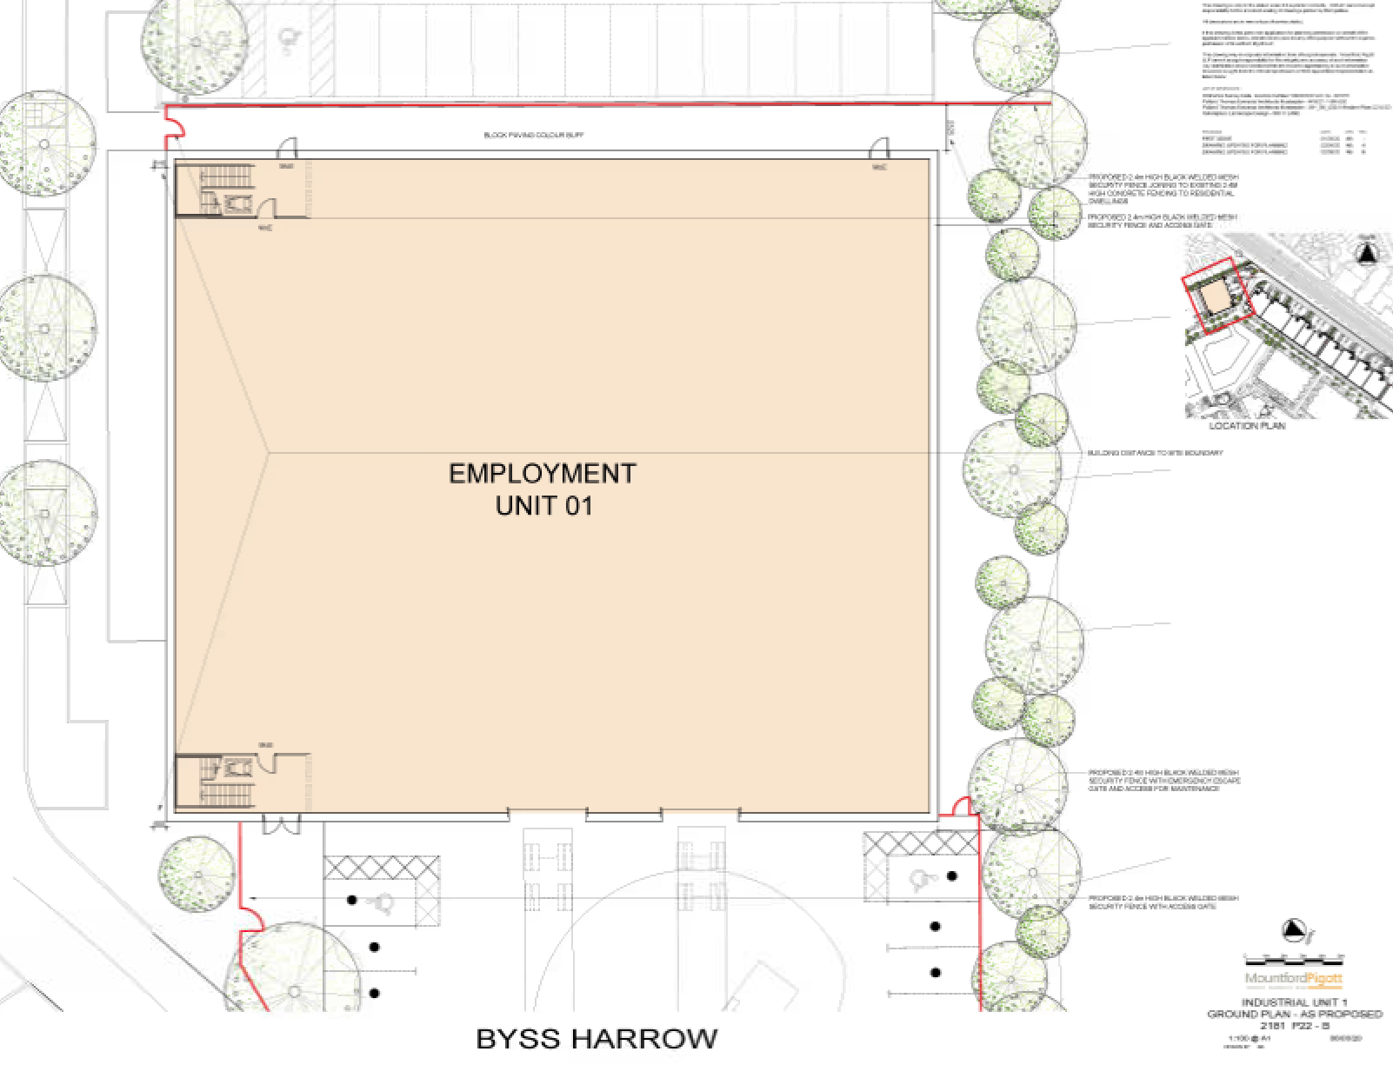

Roof Plan

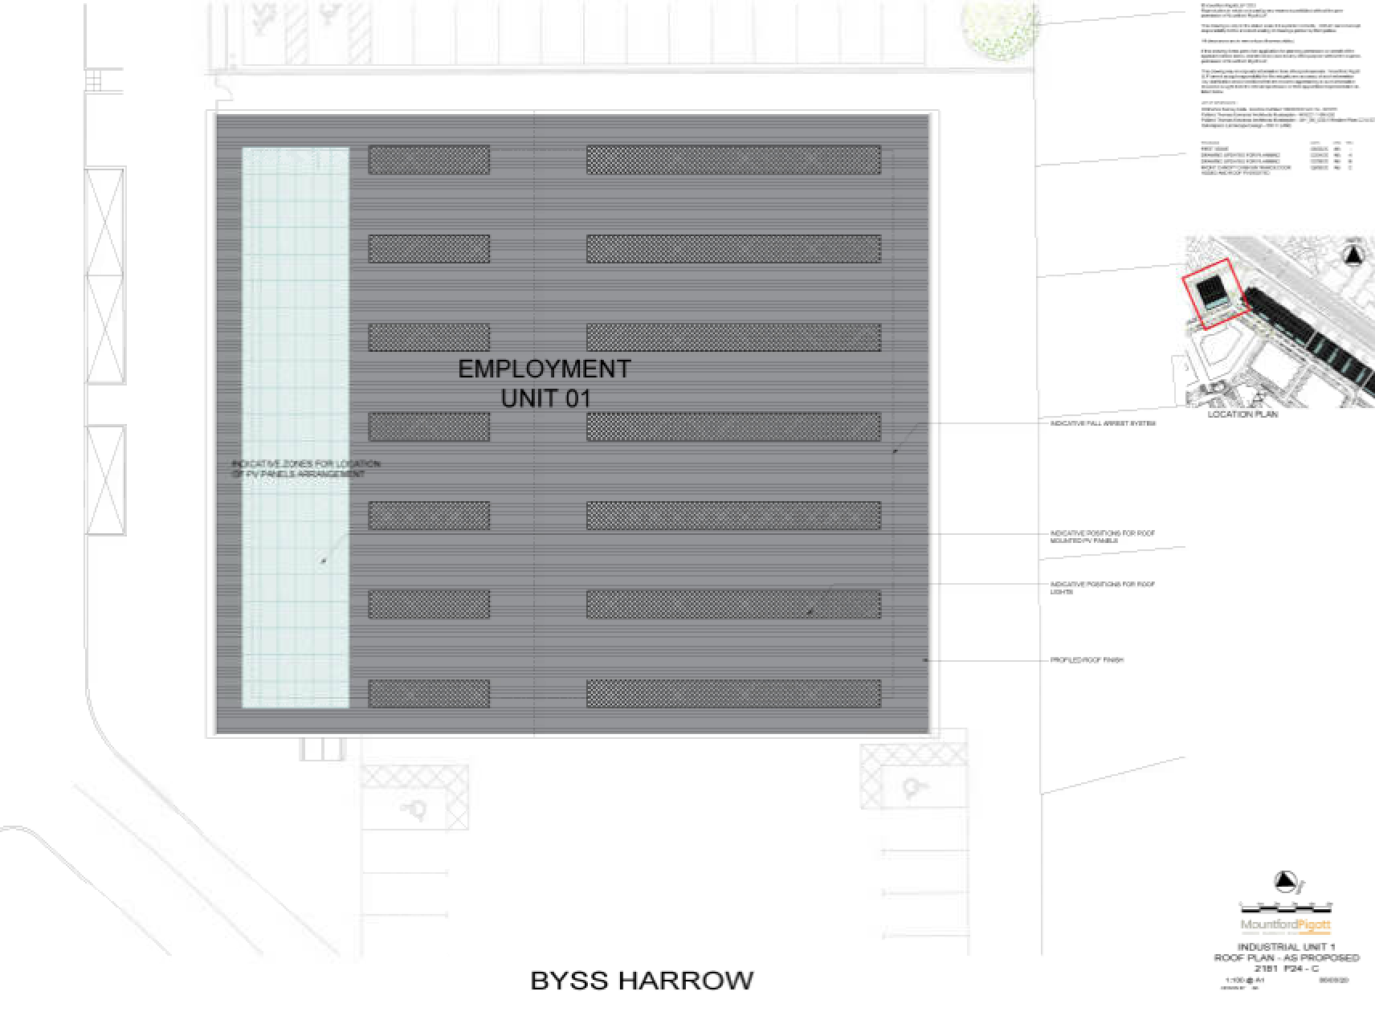

Elevations 1

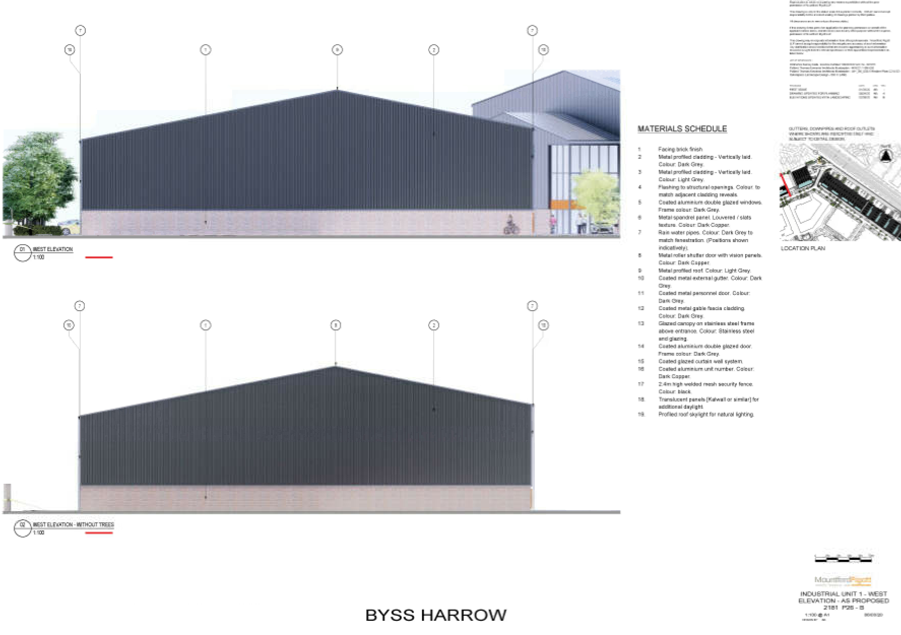

Elevations 2

